**Test Case:-**

**#. A Test Case is a set of actions executed to verify a particular feature or functionality of an software application.**

**#. Test Case is a document that covers all the possible scenario for a specific requirement.**

**#. A Test Case contains Test Step, Test Data, Pre-Condition, Expected Result, Test Case id, Actions, Requirement id,System/Application, Environment.**

**#. The Test case include specific conditions which a 'Test Engineer' can compare the expeceted result and Actual Result**

**to determine whether a software application is functioning as per the requirement of the customer/client.**

**Test Scenario:-**

**1. Verify the login functionality.**

**Best Practice for Writing Good Test Cases:-**

**1. Simple**

**2. Keep End User in Mind.**

**3. Avoid Repetation.**

**4. Do Not Assume**

**5. Peer Review.**

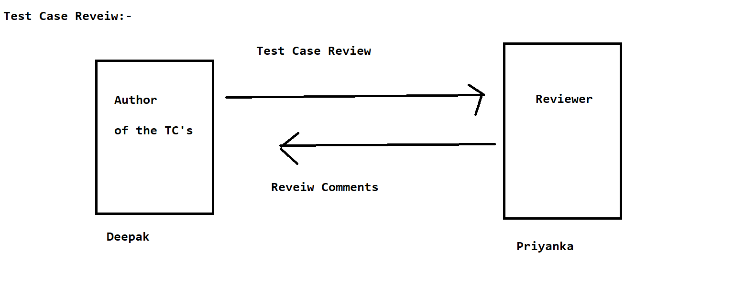

**RTM ( Requirement Traceablity Matrix ) / TM ( Traceablity Matrix)**

**#. It is a document through which you can make sure that every requirement has atleast one test case written.**

**Types of RTM:-**

**1. Forward Traceablity Matrix:-**

**#. Mapping from the base document to derive document .i.e 'Requirement' to 'Test Cases' to 'Automation Script'**

**is called as Forward Traceiblity Matrix.**

**2. Backward Traceablity Matrix:-**

**#. Mapping from Derived Document to Base Document i.e Automation Script to 'Test Cases' to 'Requirement' is called as Backward Trceablity Matrix.**

**RTM ( Requirement Traceablity Matrix )**

**#. RTM describe the mapping of requirements with the Test Cases.**

**#. The main purpose of RTM is to see all Test cases are covered so that no functionality should miss while doing software testing.**

**#. RTM Parameter includes**

**- Requirement id**

**- Requirement description**

**- Test Cases IDs**

**Test Plan:-**

**#. A Test Plan is a document that describe the test scope,objective,test strategy, schedule, deliverables and resources required to perform testing for a software product.**

**Test Plan Template Contents are:-**

**- Overview**

**- Scope**

**\*Inclusion**

**\*Test Environments**

**\*Exclusion**

**- Test Strategy**

**- Defect reporting Procedure**

**- Roles/Responsibilities**

**-Test Schedule**

**- Test Deliverables**

**- Entry and Exit Creteria**

**- Tools**

**- Risk and Mitigations**

**- Approvals.**

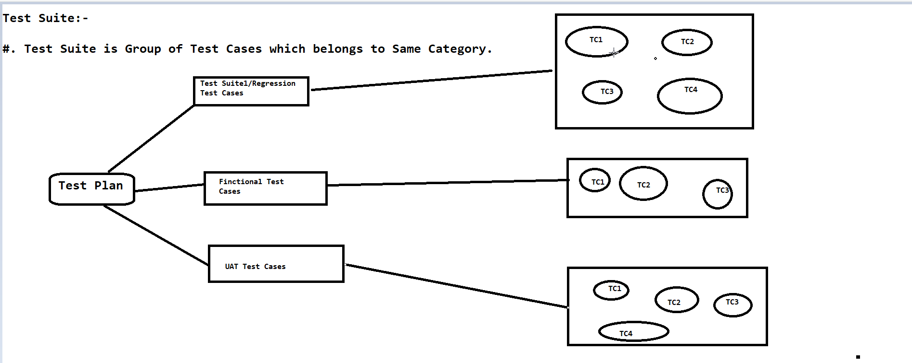

**Test Environment:-**

**#. Test Environment is a platform specially build for a test cases execution on the software product.**

**#. It is created with proper configurations.**

**#. Test Environment simulates production/real environment.**

**#. Another Term/Name of Test Environment is 'Test Bed'.**

**Test Execution:-**

**#. During this phase test team will carry out testing based on the test plans and Test Cases Prepared.**

**#. Entry Creteria :- Test Cases, Test Data, Test Environment**

**Activities:-**

**#. Test Cases are Executed based on the Test Planning.**

**#. Status of Test Cases are marked like Passed,Failed,Blocked,and Other.**

**#. Documentaion of the Test Result and log/create defects for failed Test Cases.**

**#. All Blocked and Failed Test Cases are linked with the bug/defect ids.**

**#. ReTesting once the defects are fixed.**

**#. Defects are traceked till closure.**

**Deliverables:-**

**#. Provide the defect and Test Cases execution report with completed result.**

**Guidelines for Test Execution:-**

**#. The Build being deployed to the Testing Environment is the most important part of the test execution cycle.**

**#. Test Execution is done in Testing Environment.**

**#. Test Execution happens in multiple cycle.**

**#. Test Execution phase consist Execution of Test Cases+ Test Script ( if Automation)**